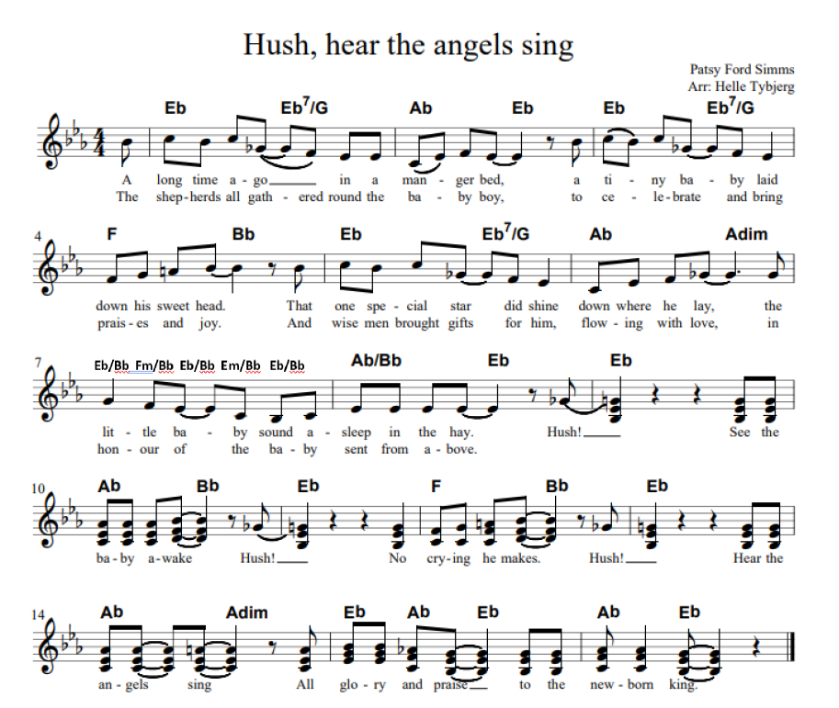

1. A long time ago in a manger bed

A tiny baby laid down his sweet head

That one special star did shine down where he lay

The little baby sound asleep in the hay

*Hush – see the baby awake*

*Hush – no crying he makes*

*Hush – hear the angels sing*

*All glory and praise to the newborn king*

1. The shepherds all gathered ‘round the babyboy

To celebrate and bring praises and joy

And wise men brought gifts for him flowing with love

In honour of the baby sent from above

Sidste linje:

*All glory and praise, let all voices raise, all glory and praise to the newborn king*